TABLE OF CONTENTS

Angular #1

Section 1.1 #

Subsection 1.1.a #

Subsection 1.1.b #

Subsection 1.1.c #

Section 1.2 #

Section 1.3 #

Azure function app 21

Section 2.1 #

Section 2.2 #

Subsection 2.2.a #

Subsection 2.2.b #

Subsection 2.2.c #

Section 2.3 #

Chapter 3 #

Section 3.1 #

Section 3.2 #

Section 3.3 #

Subsection 3.3.a #

Subsection 3.3.b #

Subsection 3.3.c #

# Angular Installation

**Update the NPM to latest Version**

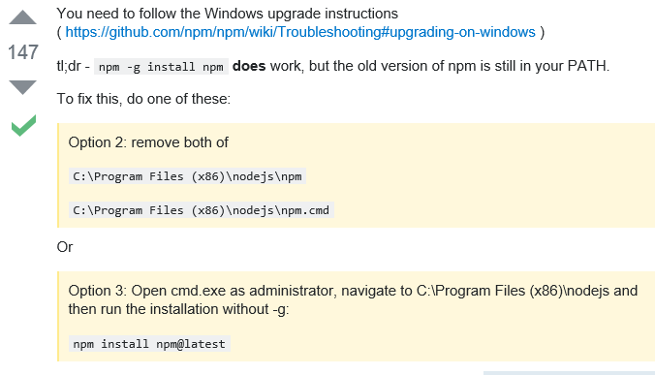

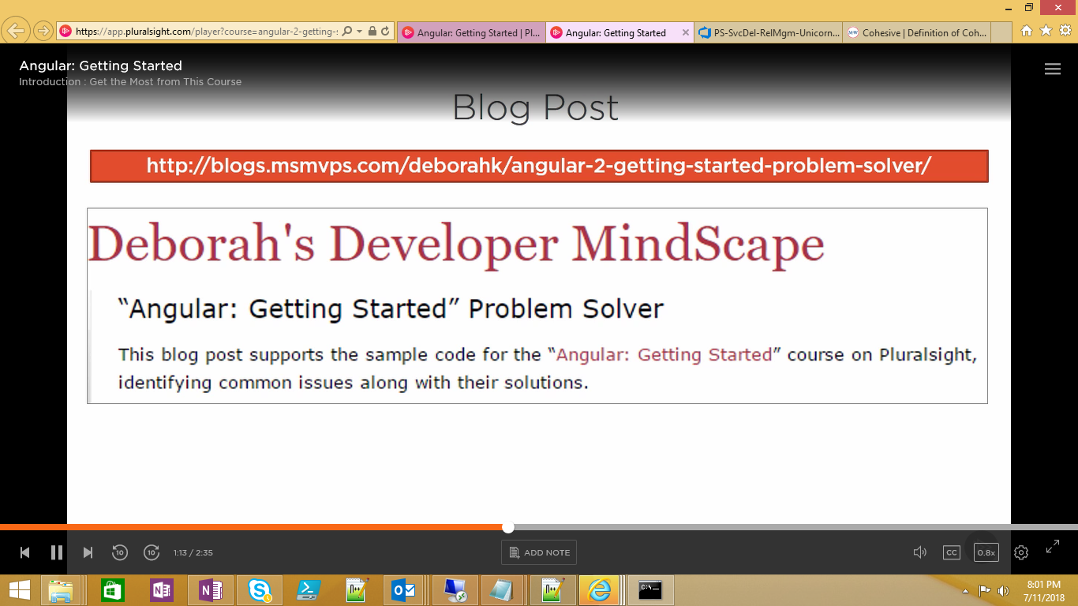

<https://blogs.msmvps.com/deborahk/angular-2-getting-started-problem-solver/>

<https://github.com/Deborahk/Angular-GettingStarted>

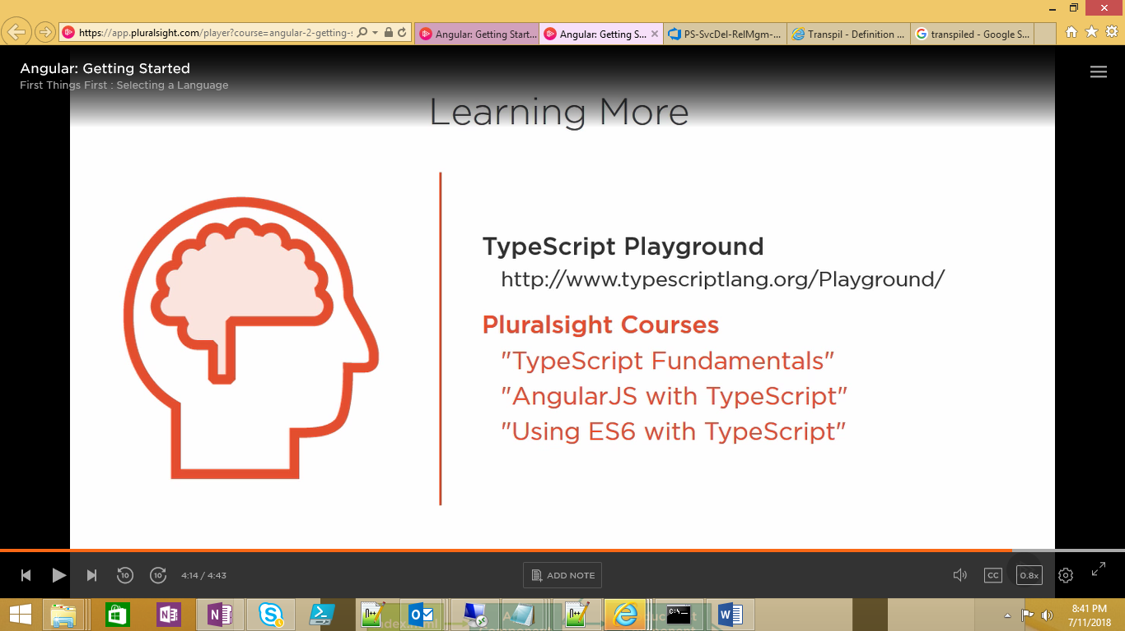

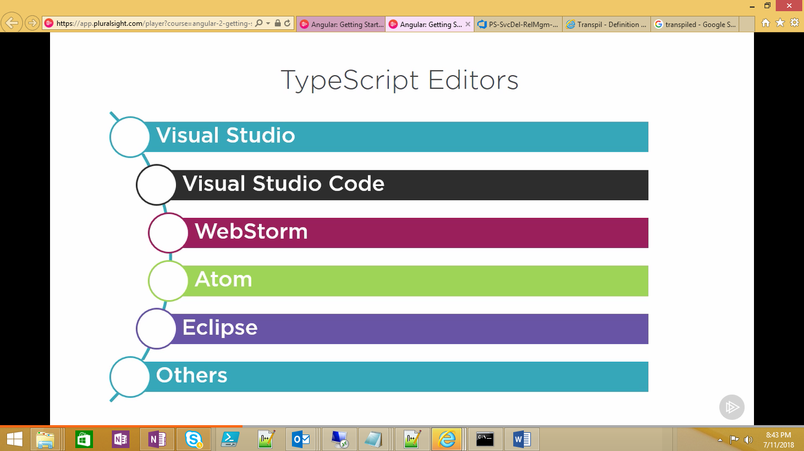

<https://code.Visualstudio.com>

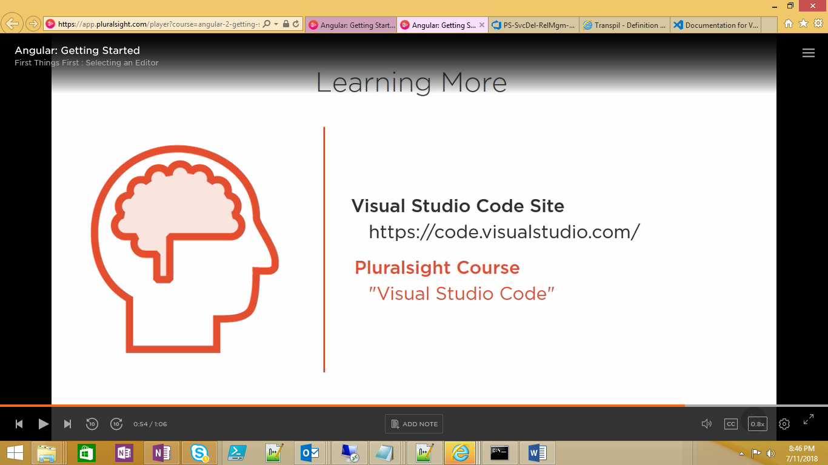

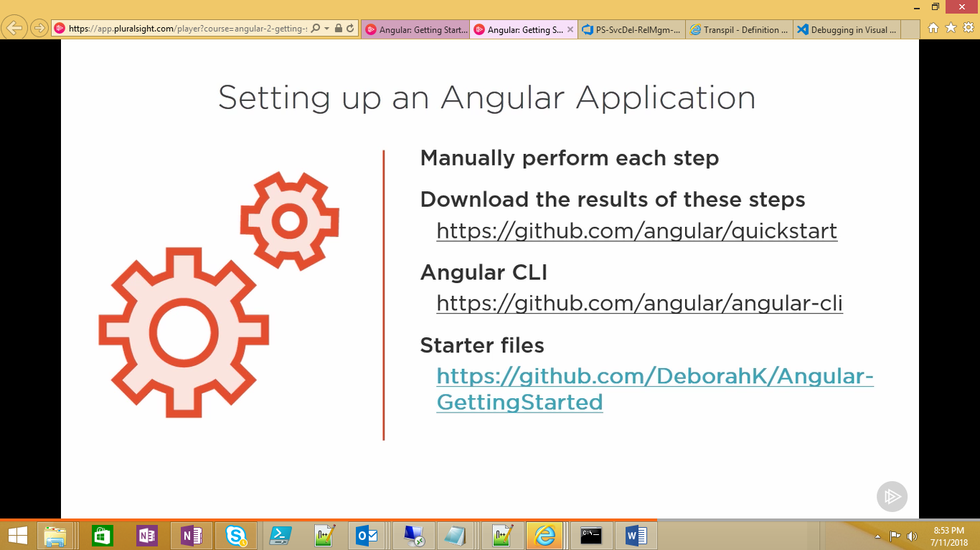

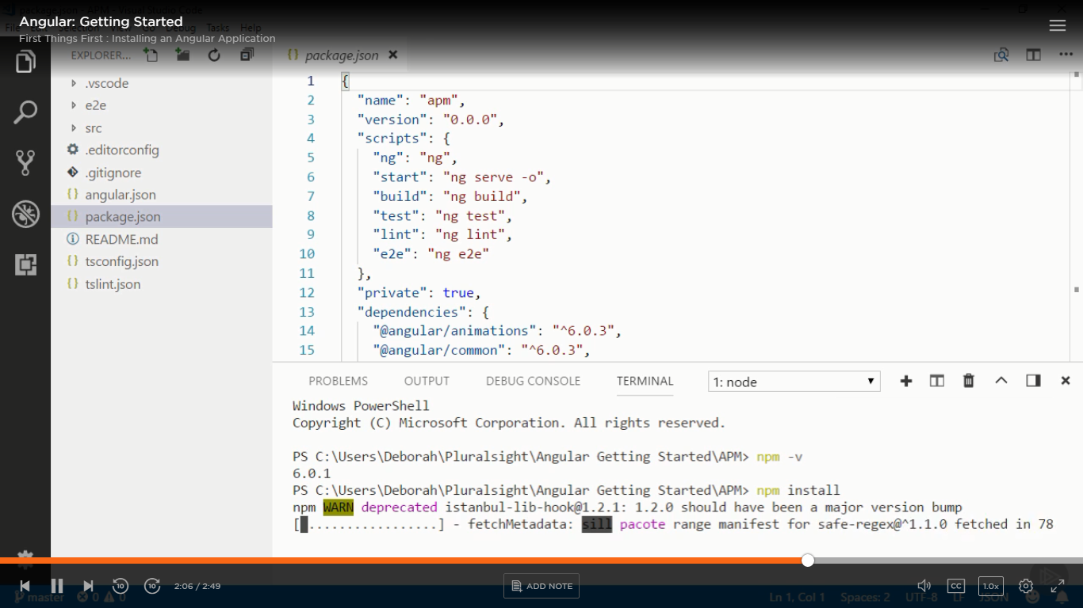

Commands:

**Npm install**

**npm start** is to start the project

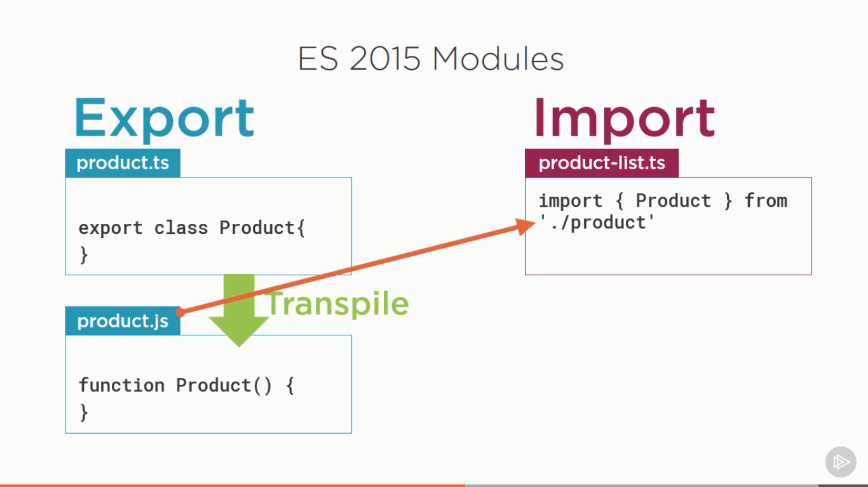

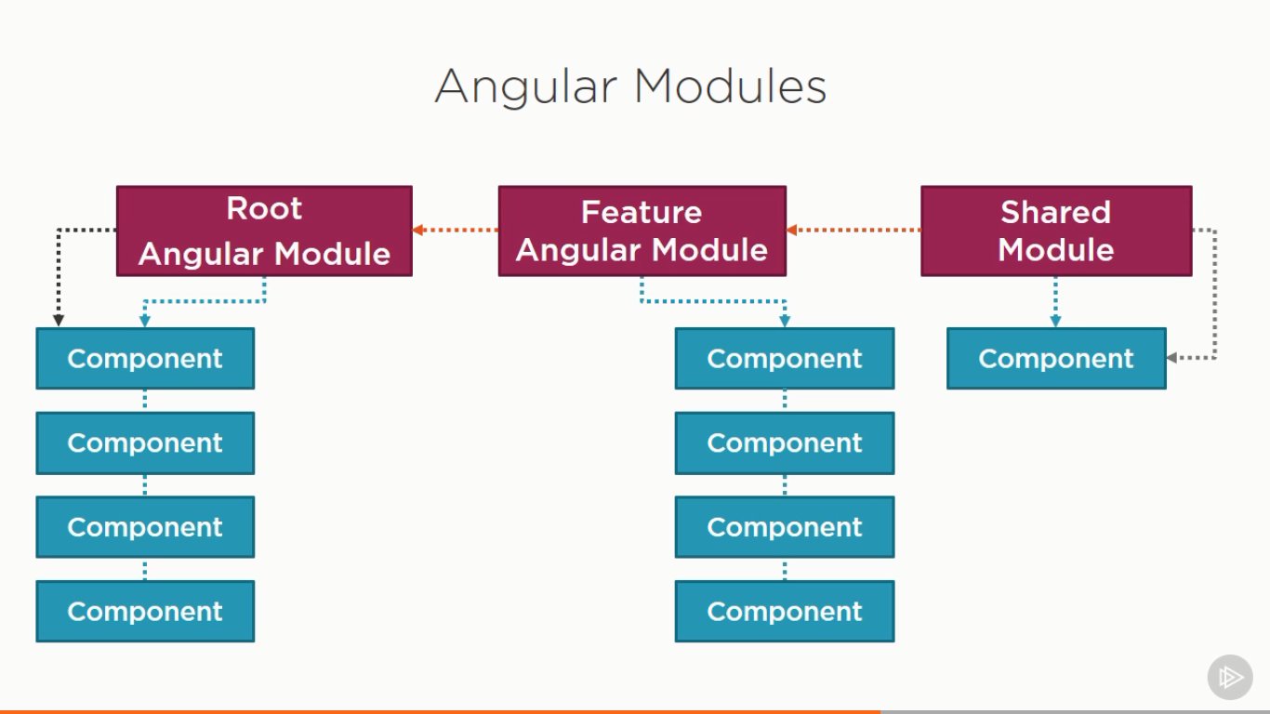

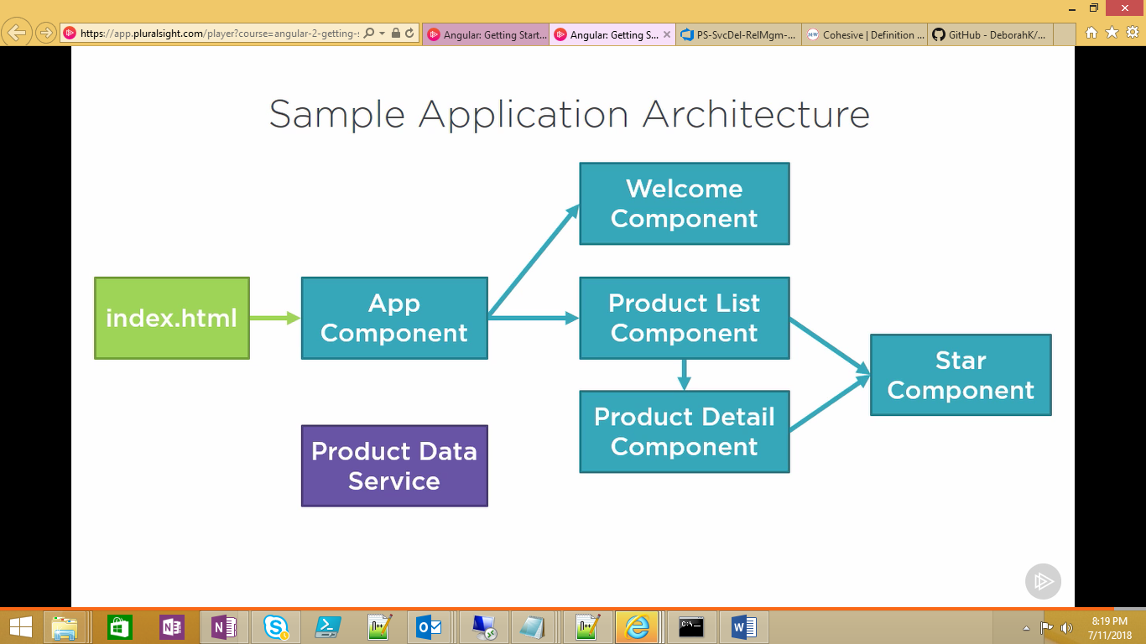

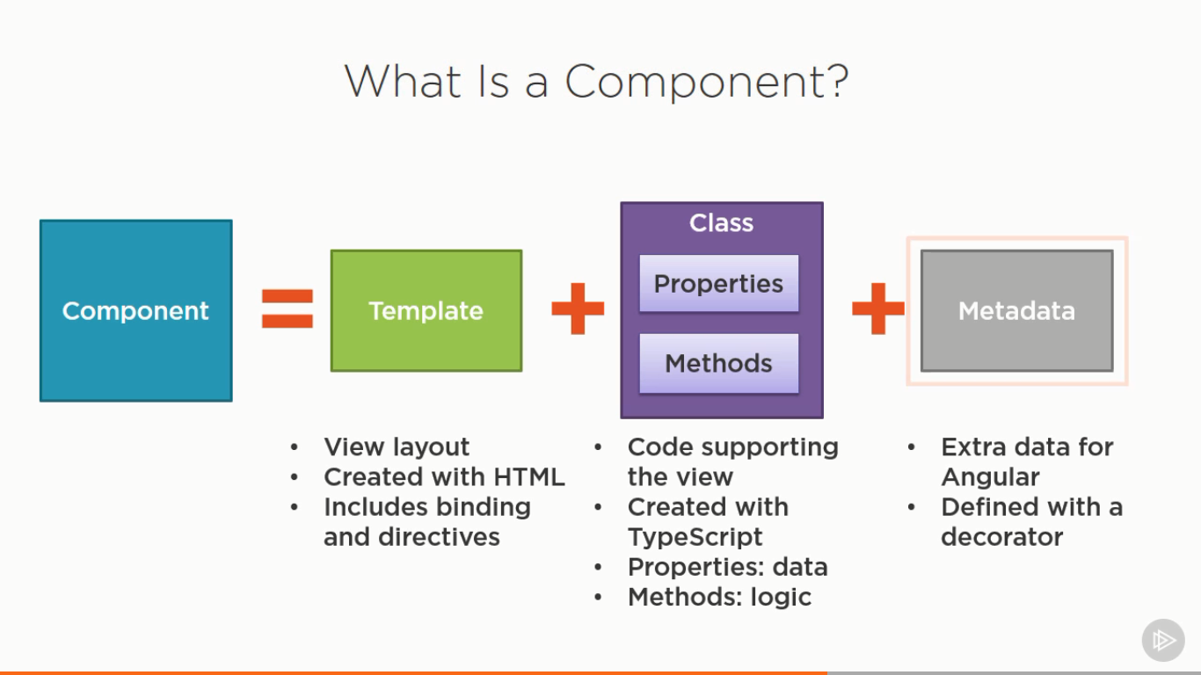

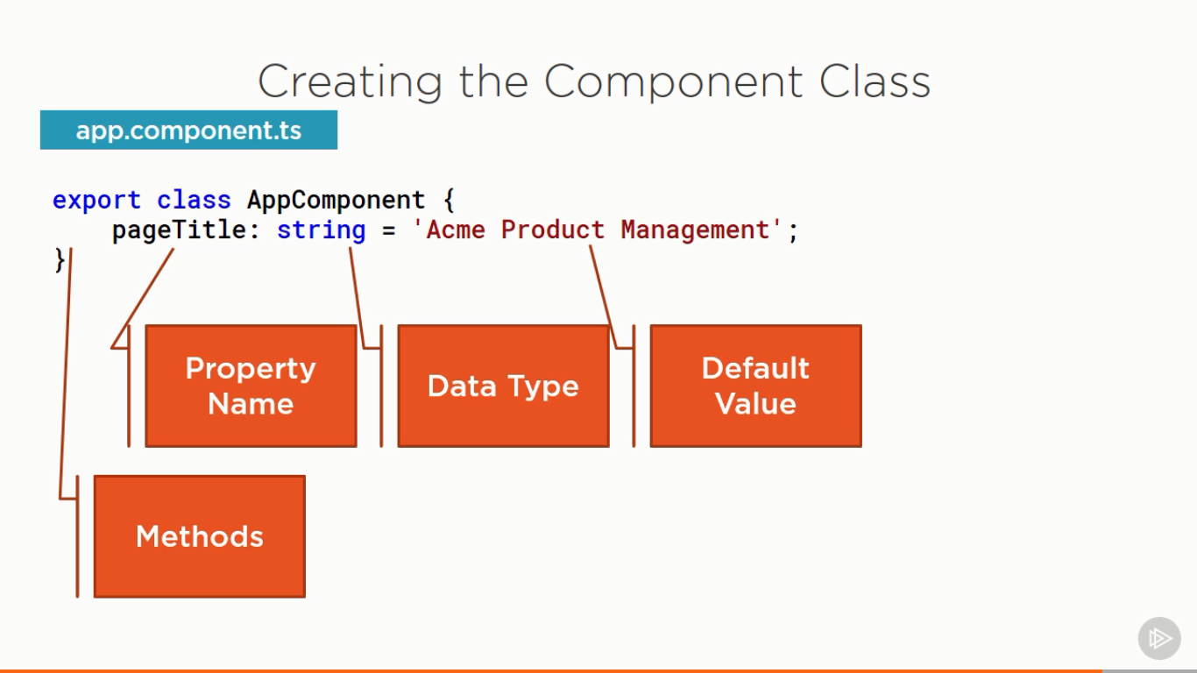

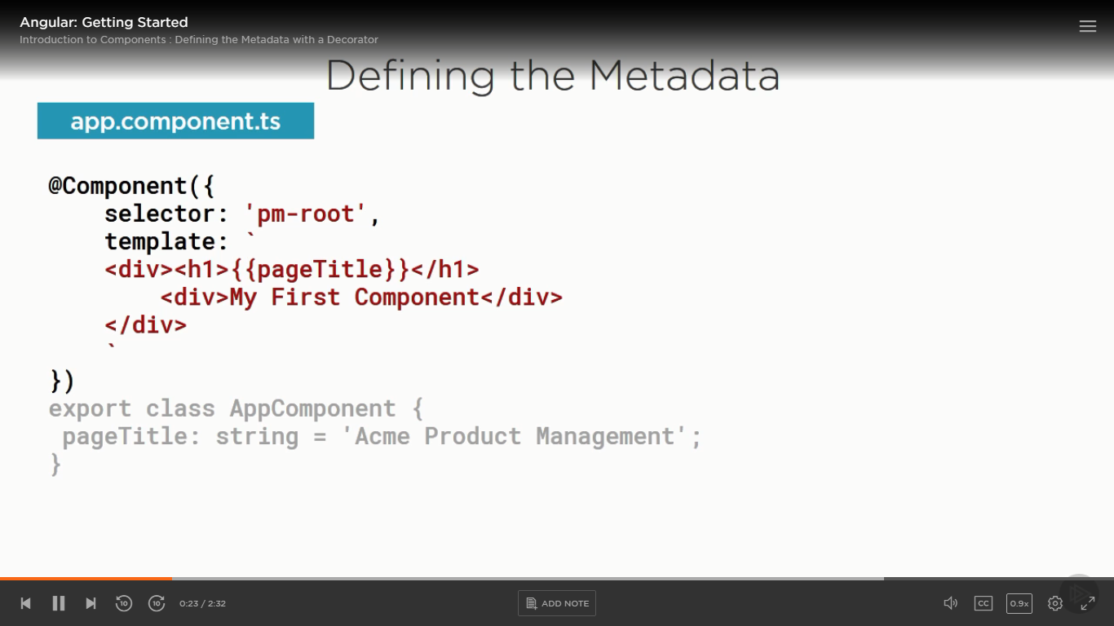

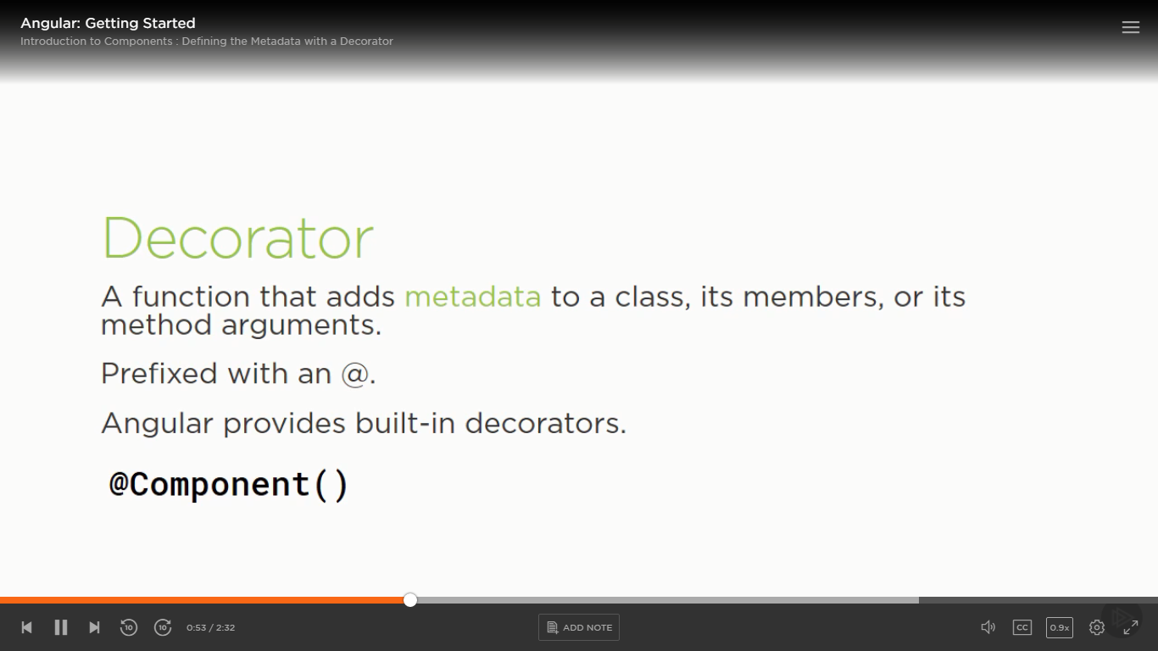

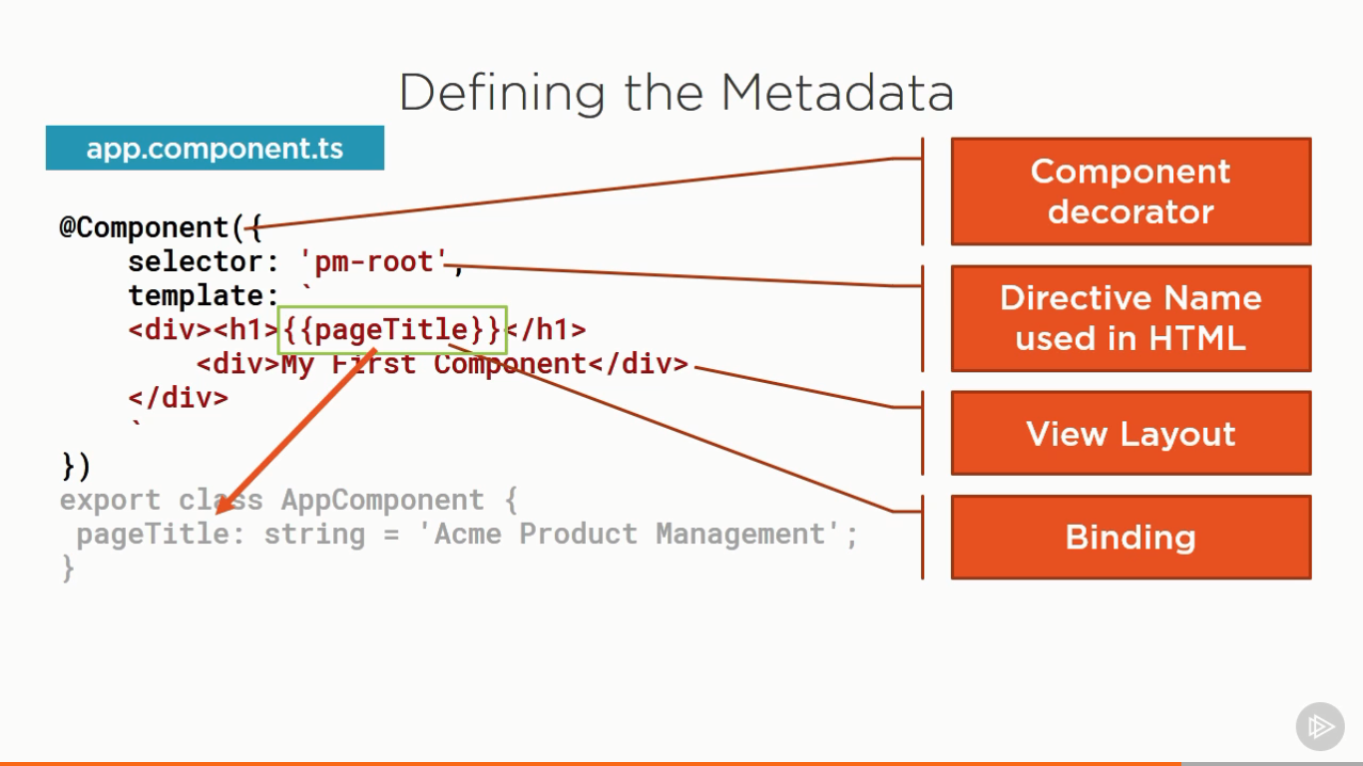

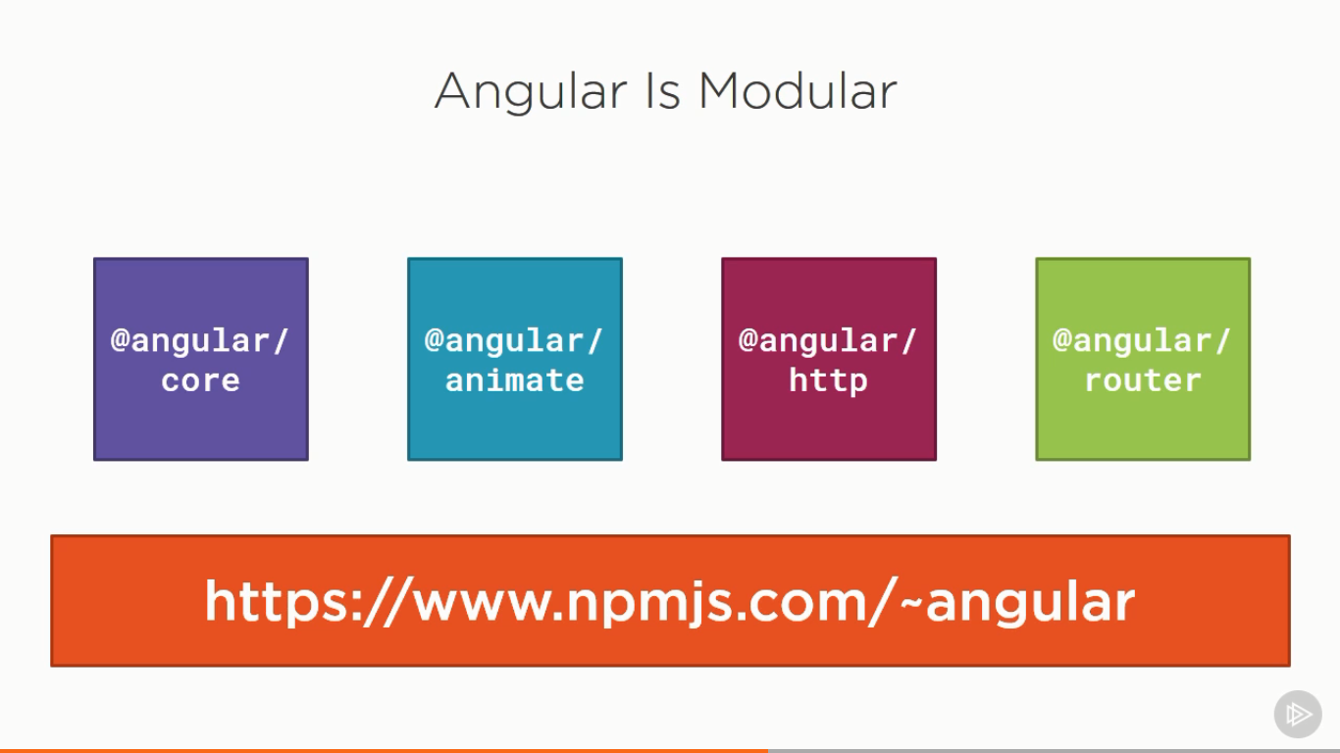

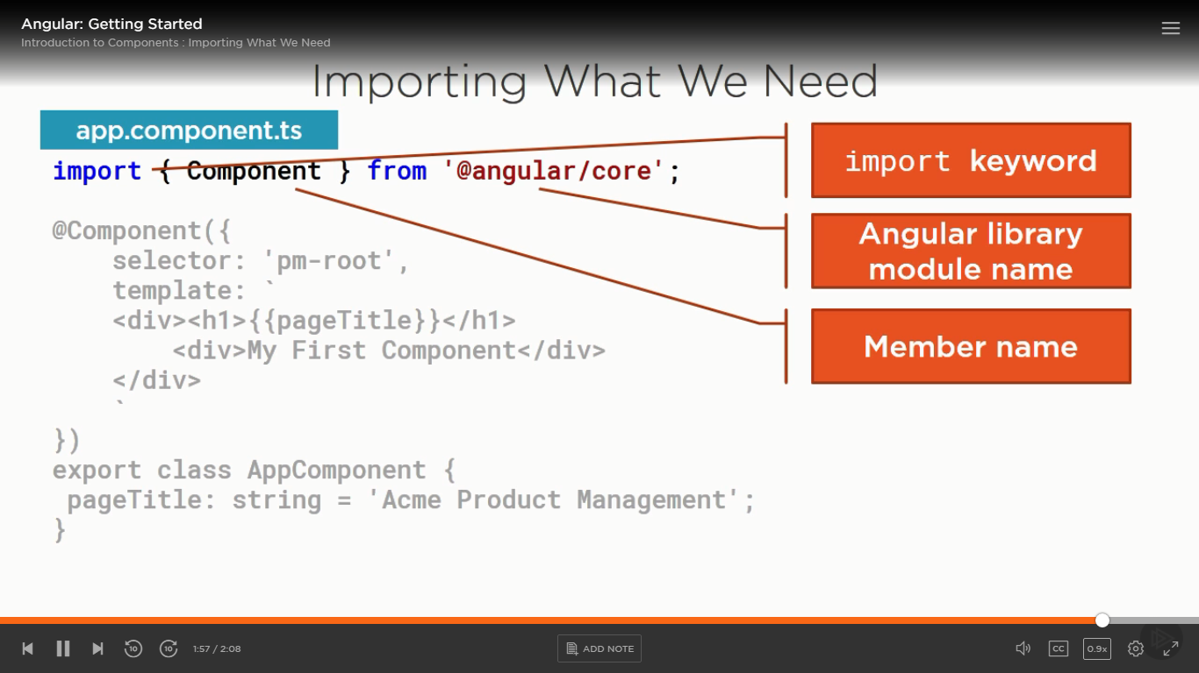

What is bootstrapping?

We need to say something to angular to start our application using root component, This process is called as bootstratpping.

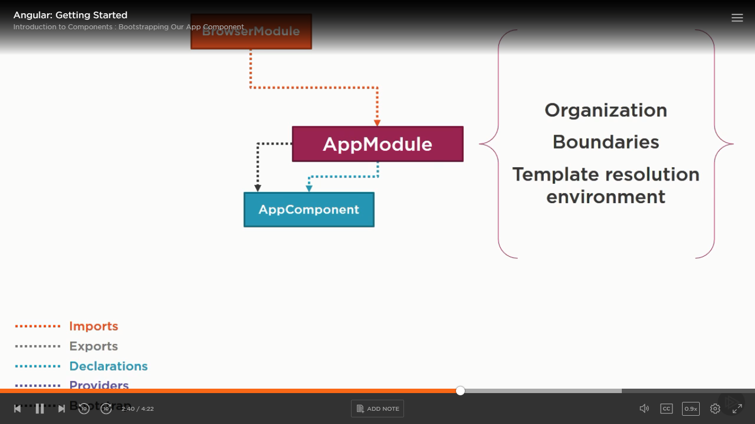

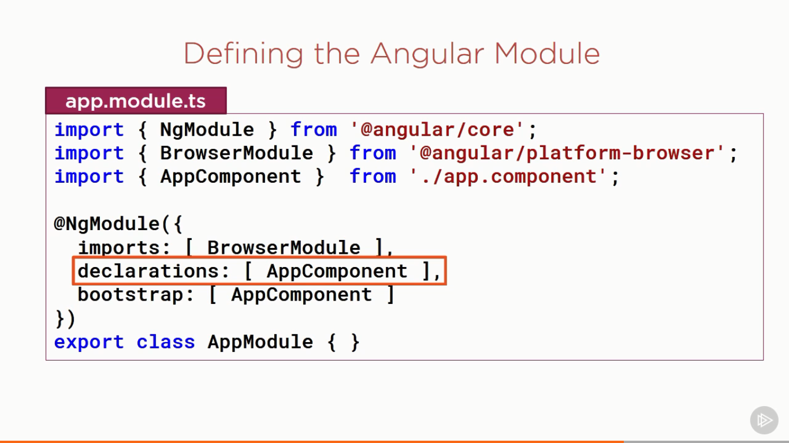

What is INTERPOLATION?

An interpolation is databinding technique used in Angular to bind the data from the component class to template

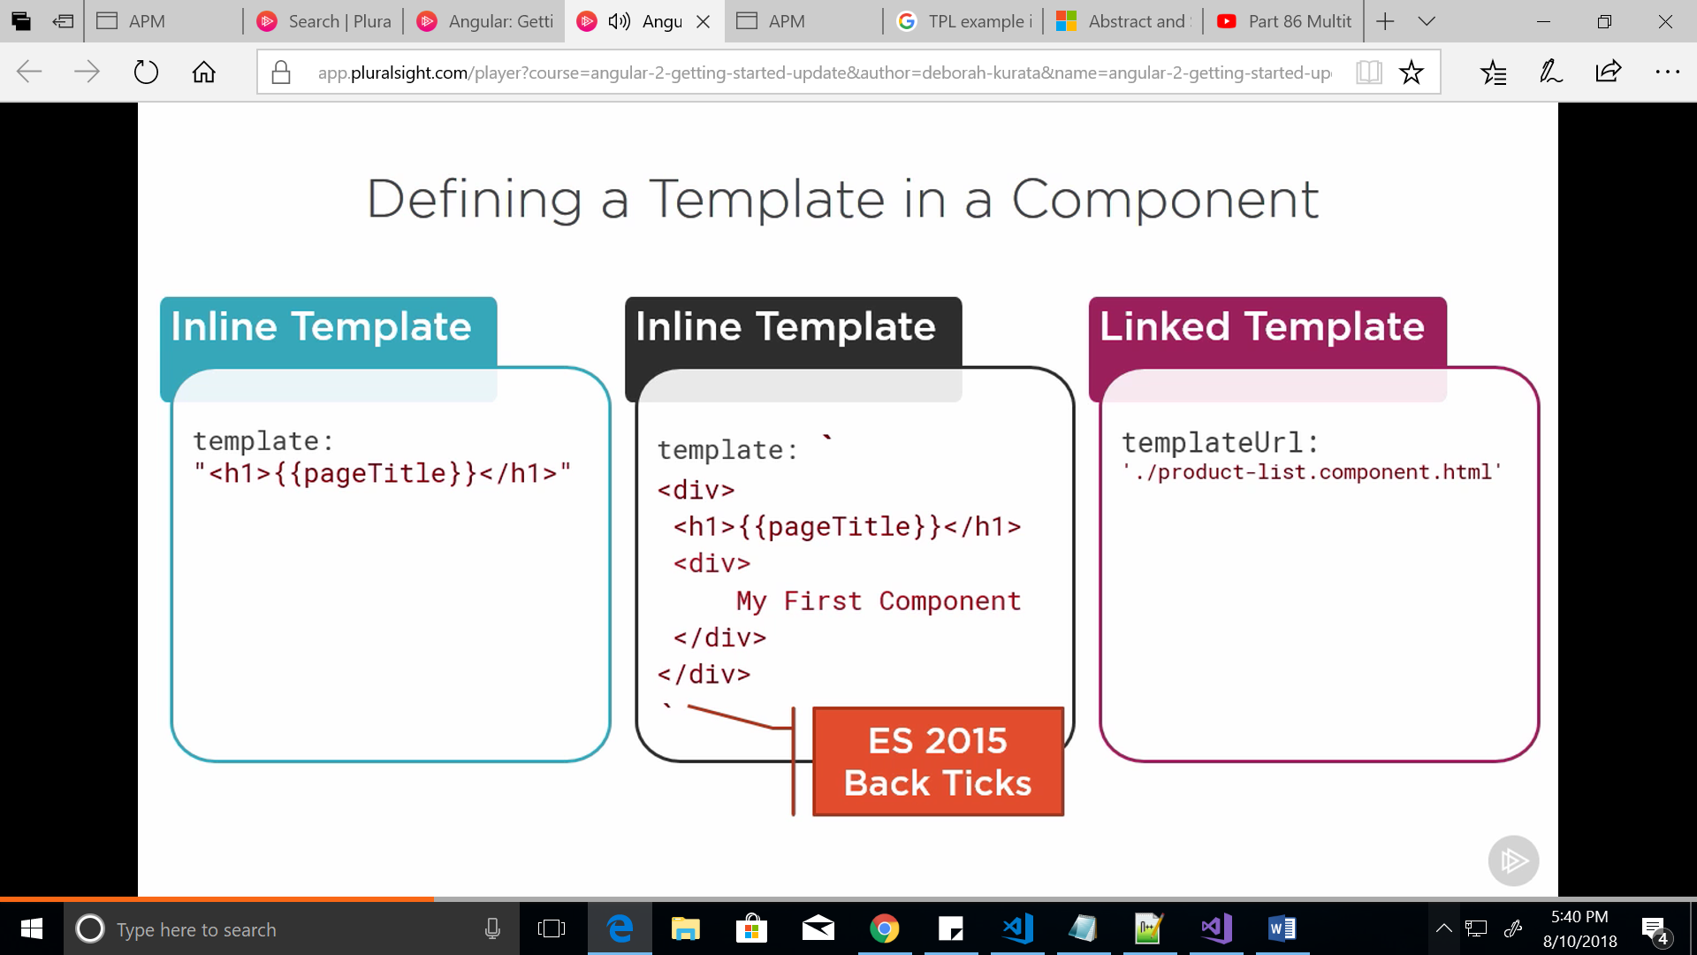

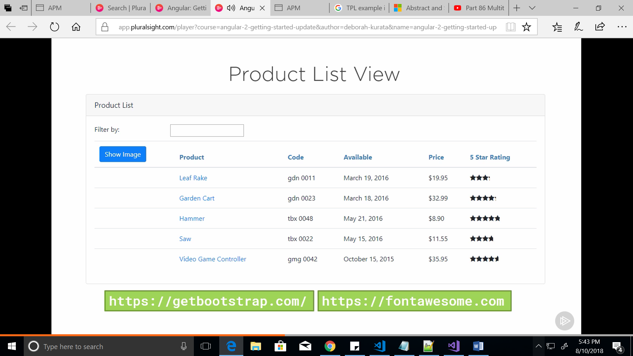

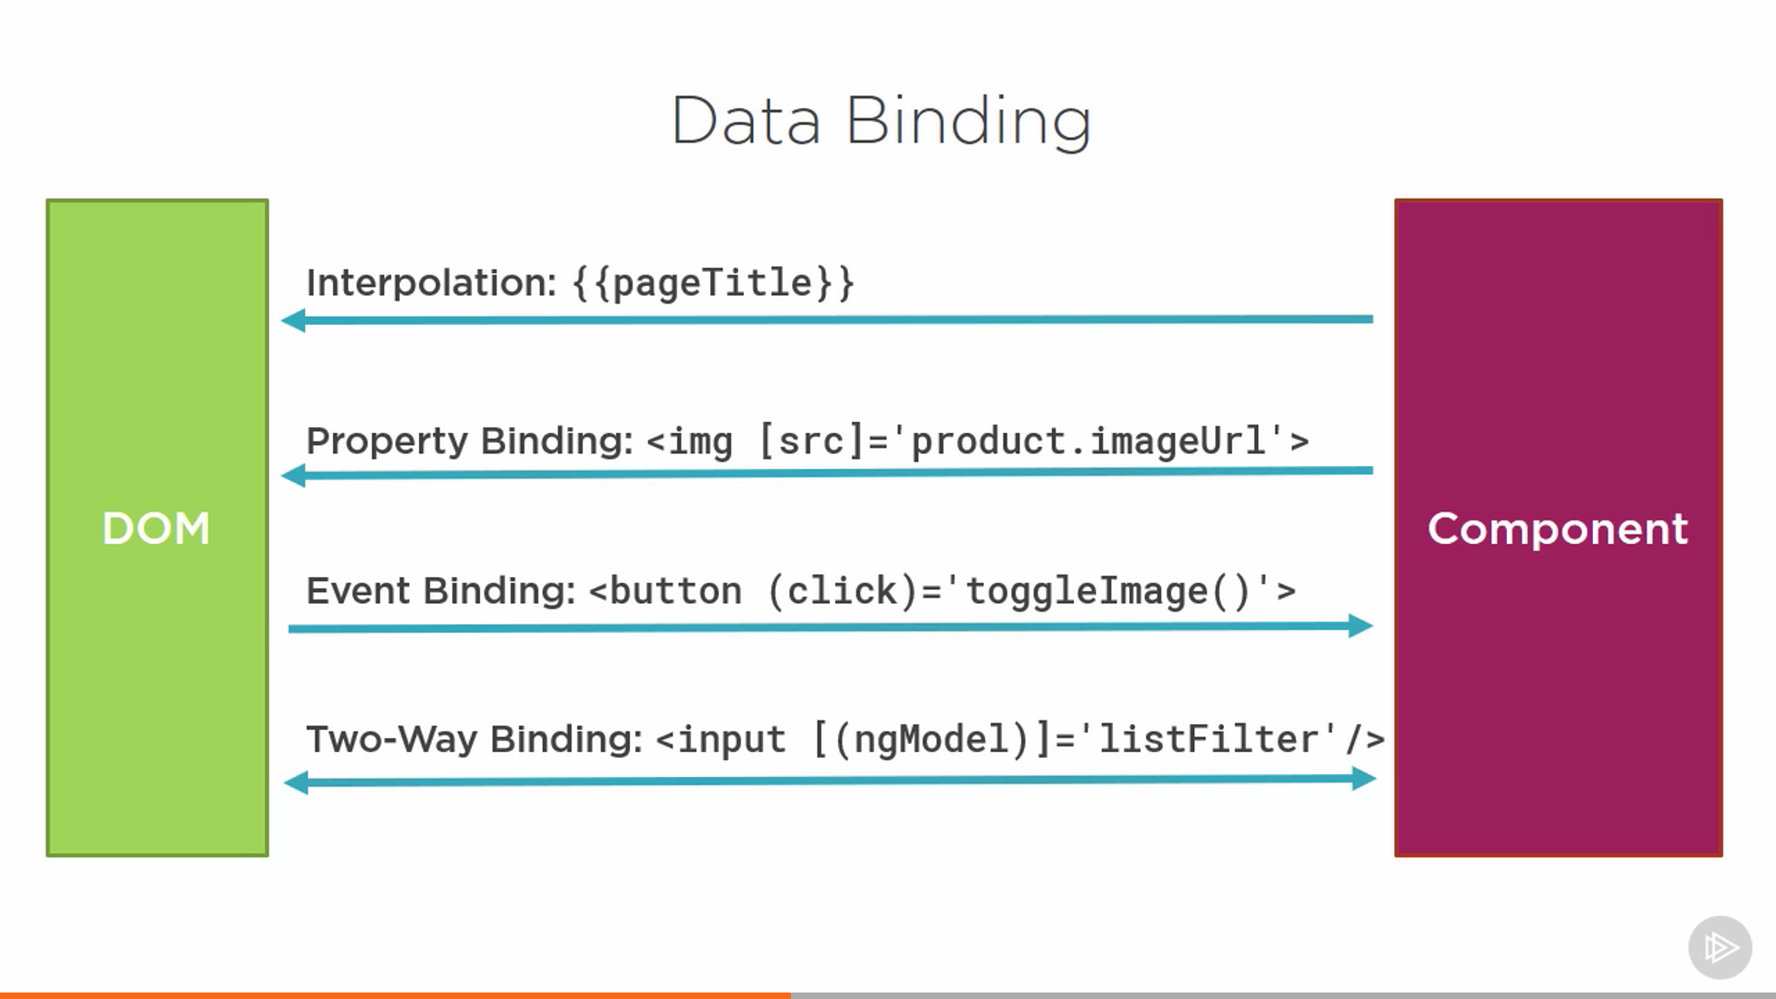

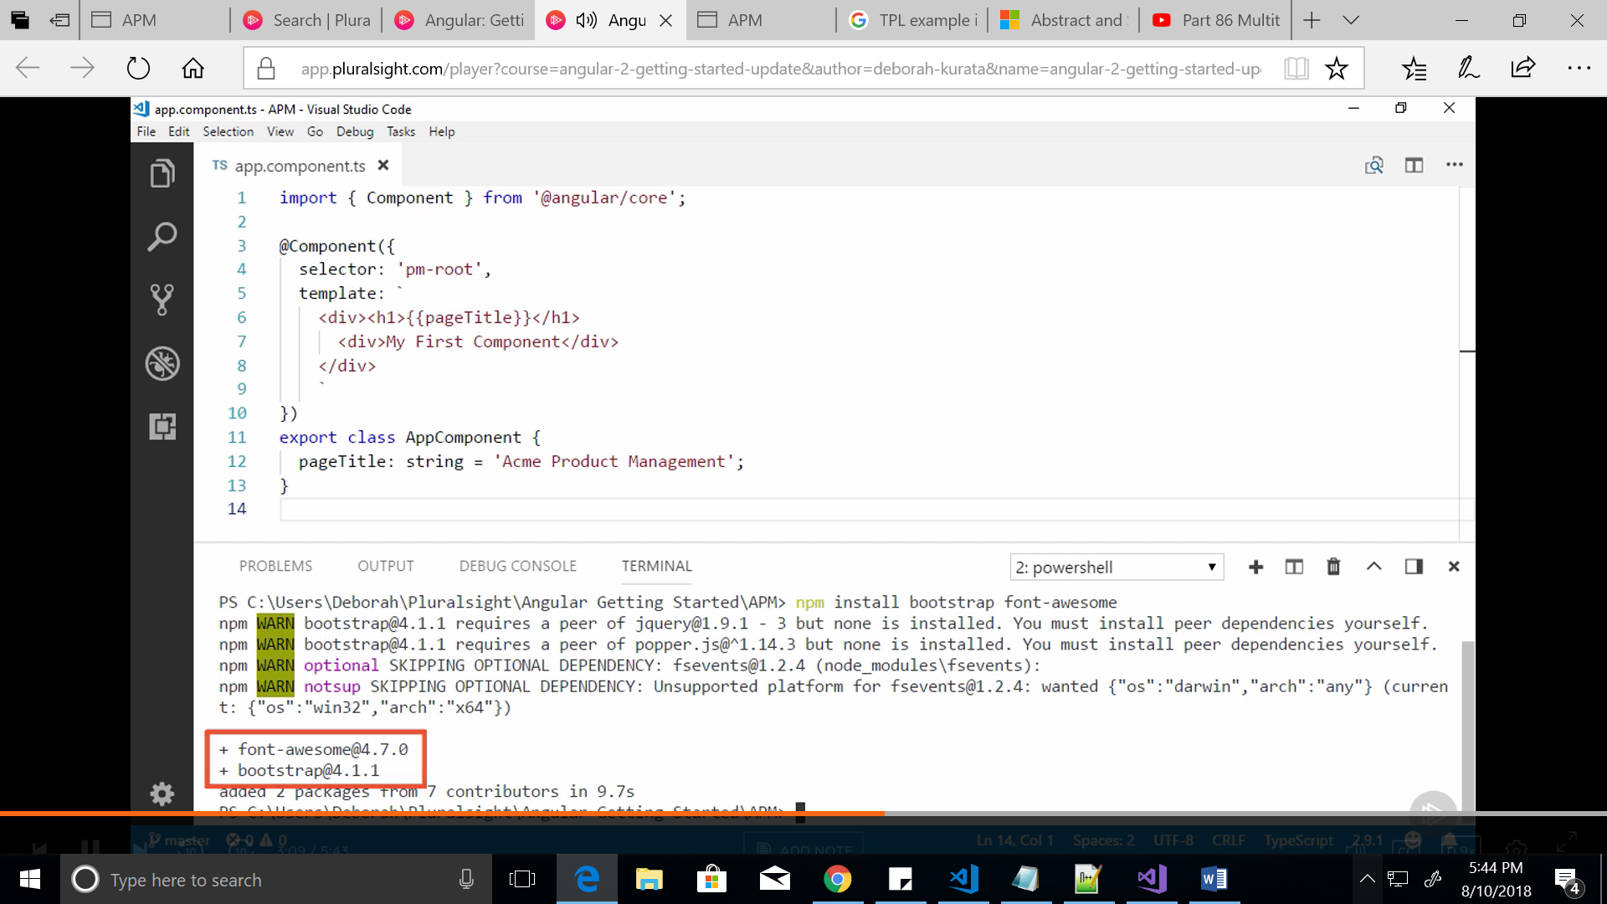

<http://blogs.msmvps.com/deborahk/anuglar-2-getting-started-problem-solver/>

Built In Pipes :

| 🡪 is called a pipe symbol

{{ product.price | currency : ‘USD’ : ‘$’:’1.2-2’}}

The above line shows pipes with parameters

We can the chain the pipes by adding multiple | symbol

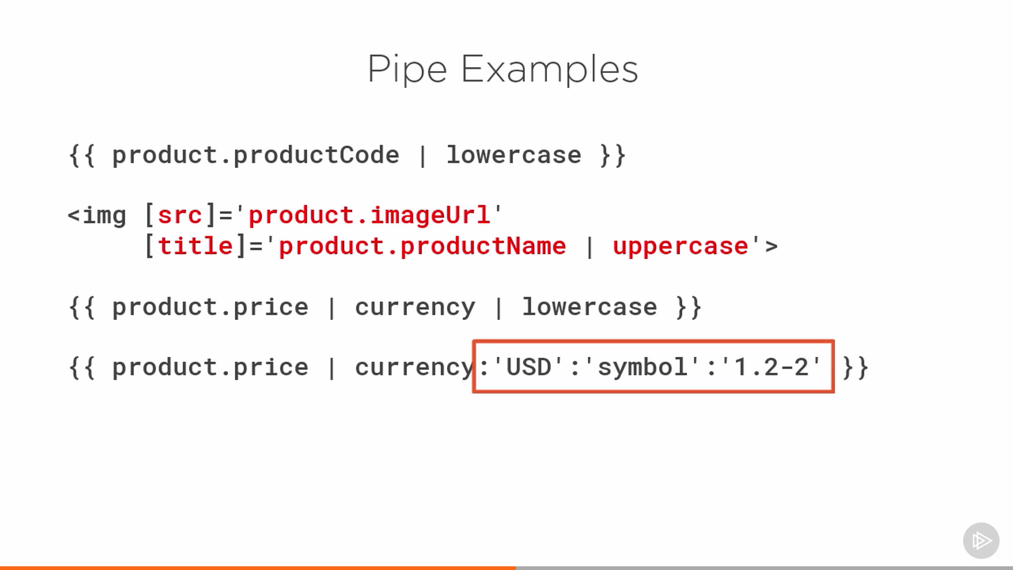

Building the Custom pipes

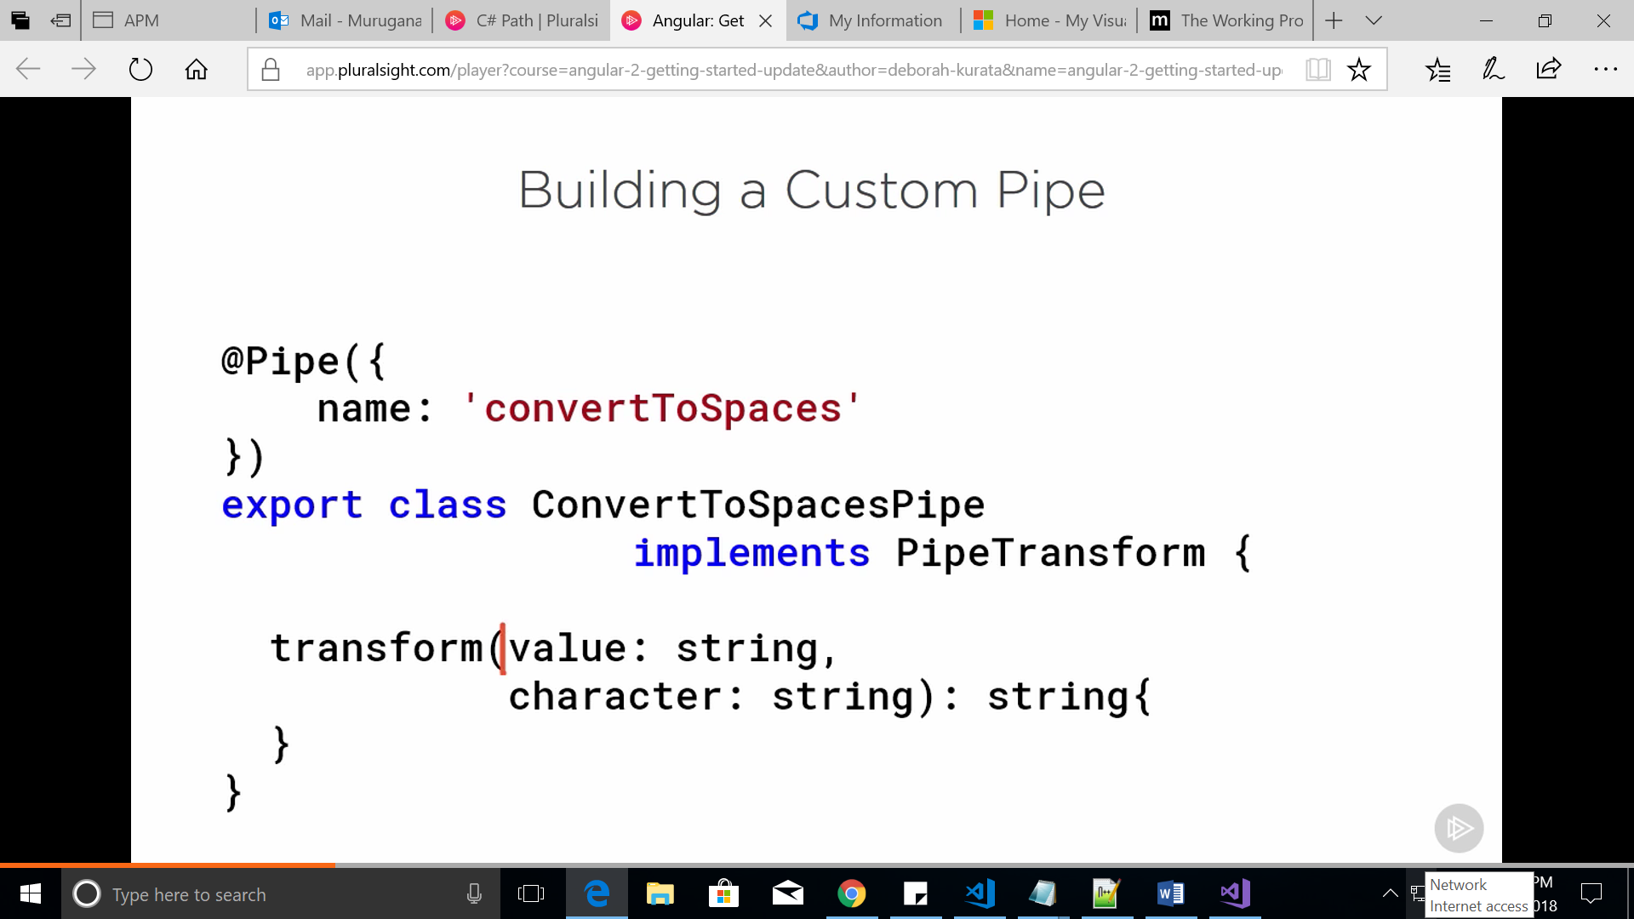

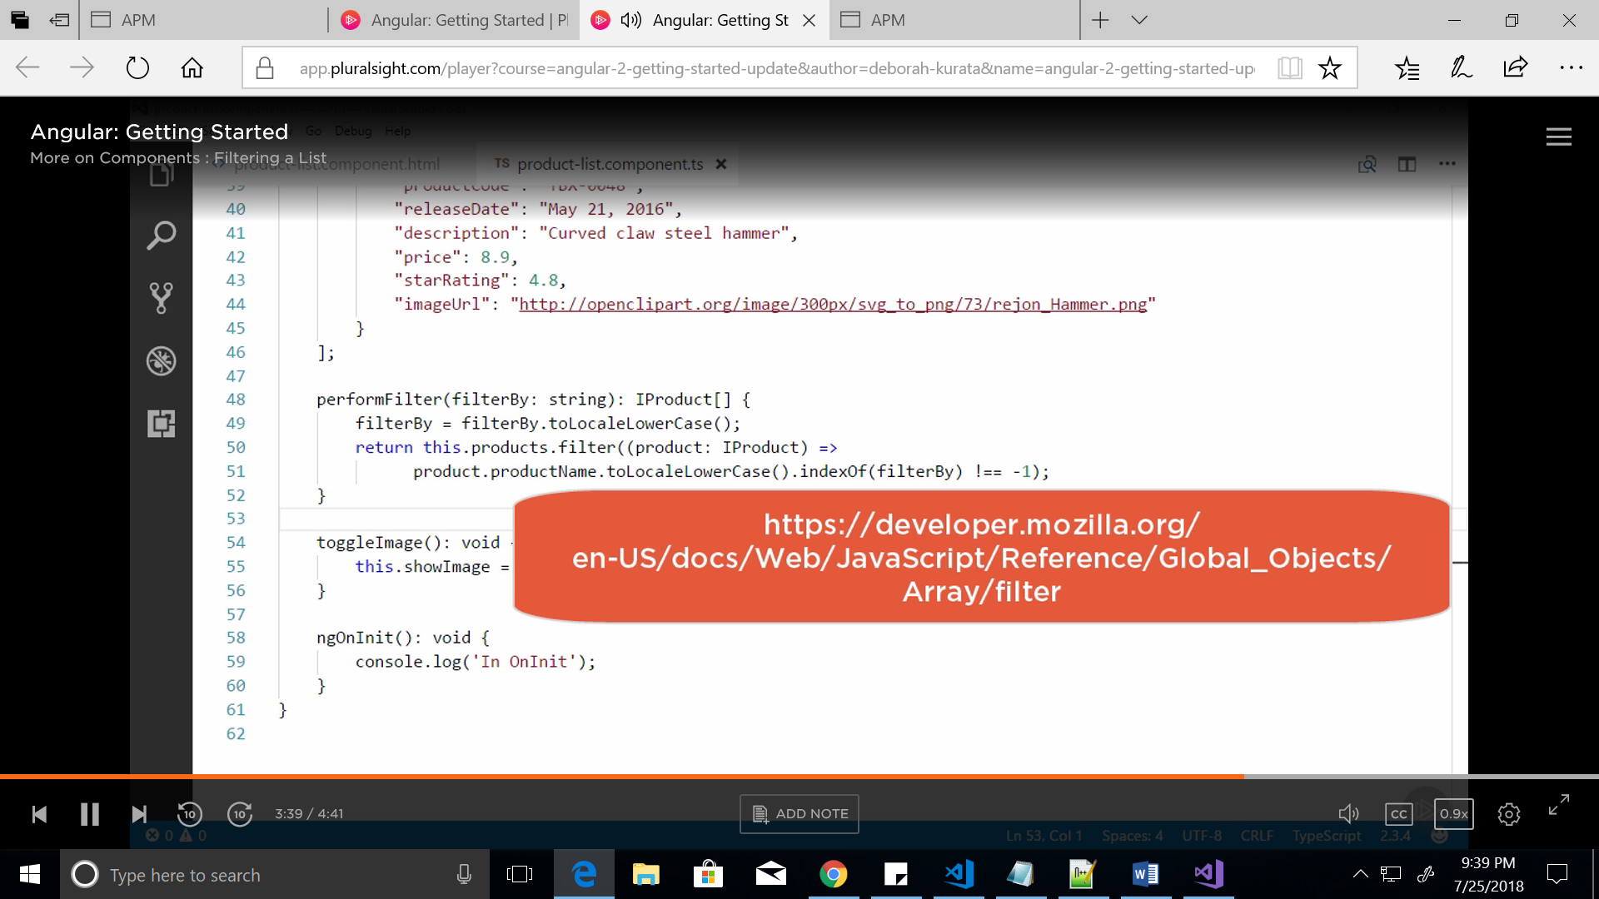

# AZURE Function APPs

Azure Functions Core Tools command line Interface

github.com/Azure/Azure-Functions-cli

